130089872

Are a select few Impacting the personal opinions and decision making of twitter users? 2010-2020

Contents

Table of Figures 2

Acknowledgements 3

Introduction 3

Supporting how easy it is to create a trending topic 4

How the research was gathered. 4

Has your opinion been changed by social media? 4

Has a social media influencer ever changed your stance on a topic? 5

Has news appeared to you at a convenient time? 6

Telling the difference between real and fake news? 7

Detecting fake news continuation. 7

The most frequent social media platform used to gather news 9

The frequency of viewing social media 9

Conclusion 10

Bibliography 11

# Table of Figures

Figure 1 Trending topics can be misleading 3

Figure 2 Evidence of misleading topics 3

Figure 3 Supporting evidence - changed opinions 4

Figure 4 Supporting evidence - popularity matters to an opinion 5

Figure 5 Supporting evidence - social media Influencer 5

Figure 6 Supporting evidence - convenient news articles 6

Figure 7 Supporting evidence – detecting fake News 7

Figure 8 Supporting evidence - users cannot detect fake news 7

Figure 9 Do sharks like a jazz news article (Tama/Getty, 2018) 8

Figure 10 Vape pens to be banned in the UK? news article (Smallwood 2020) 8

Figure 11 Supporting that Twitter was the most frequent 9

Figure 12 supports how frequent social media is checked 9

Figure 13 Supporting Evidence repeated information 10

# Acknowledgements

This research was supported by friends, family and the Templar Trading Community.

# Introduction

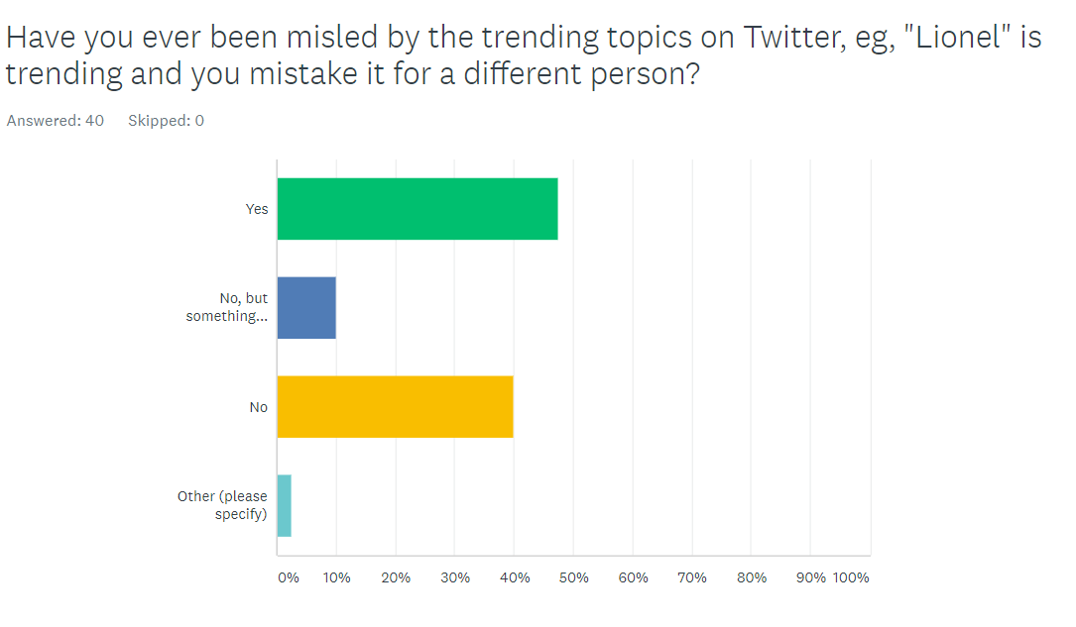This document will look at fake news on Twitter. On twitter, it is very easy to create fake news, as if one person starts talking about a topic and it gains enough traction. it will become a trending topic. A trending topic is simply created by several people talking about a certain word in a short amount of time or using a # and a phrase. For example (figure 1), on the 6th of November, the word Lionel is a trending topic. Which was referring to Lionel Messi. This can be misleading as it does not clearly state what the topic is referring to, till after clicking the trend. Users who will not have clicked the topic yet may assume the news is related to another topic. For example, Lionel Richie. So, users could theory craft articles that are not related to this to create false news like “Lionel Richie passed away?” it is quite common for a user to be misled by these trending phrases as shown in (figure 2).

Figure trending topics can be misleading

Figure Evidence to misleading topics

### Supporting how easy it is to create a trending topic

As (Zi Chu, 2010) states, “Most social media sites like Twitter and Facebook allow bots to be used, which boost and enhance spamming or posting messages by repeatedly sending them to as many other users as possible” This can cause a trend on Twitter over time this can be catastrophic.

# How the research was gathered.

After surveying surveymonkey.com, information was gathered. The survey looked at how fake news is perceived, whether can people detect what is fake news / do they believe they can detect it if their opinion has ever changed on a topic by the news presented to them, has news ever appeared at a convenient time, what platforms they use to browse news articles and the longest time they are away from social media.

## Has your opinion been changed by social media?

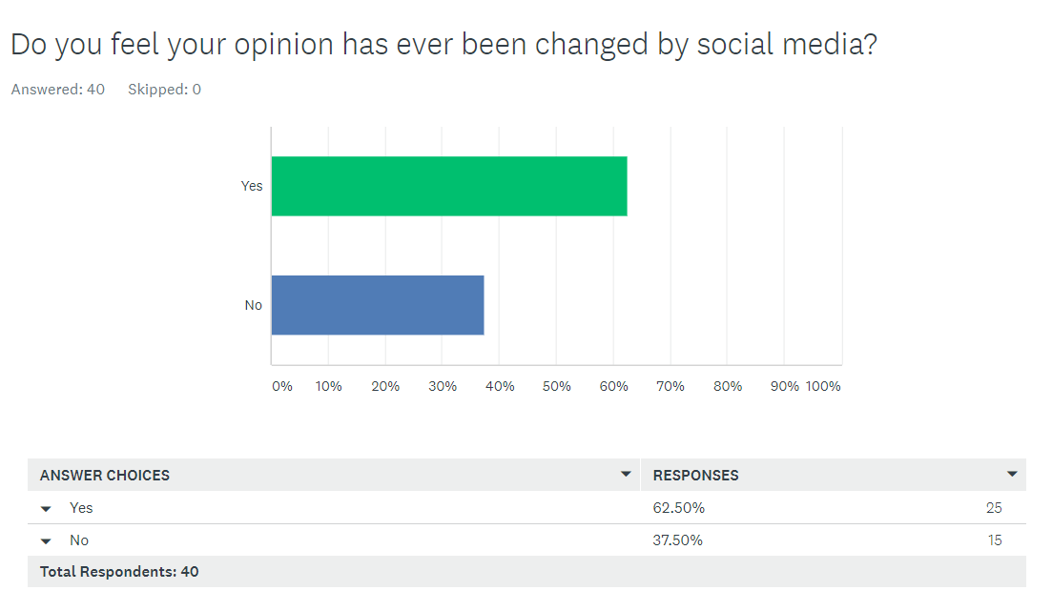As shown in (figure 3), 62% of the individuals felt their opinion has been changed by social media. This means that most users may just join a crowd/bandwagon of the most popular opinion, instead of their own without understanding both sides of an argument.

This can be supported by the next question.

Figure Supporting evidence - changed opinions

## Has a social media influencer ever changed your stance on a topic?

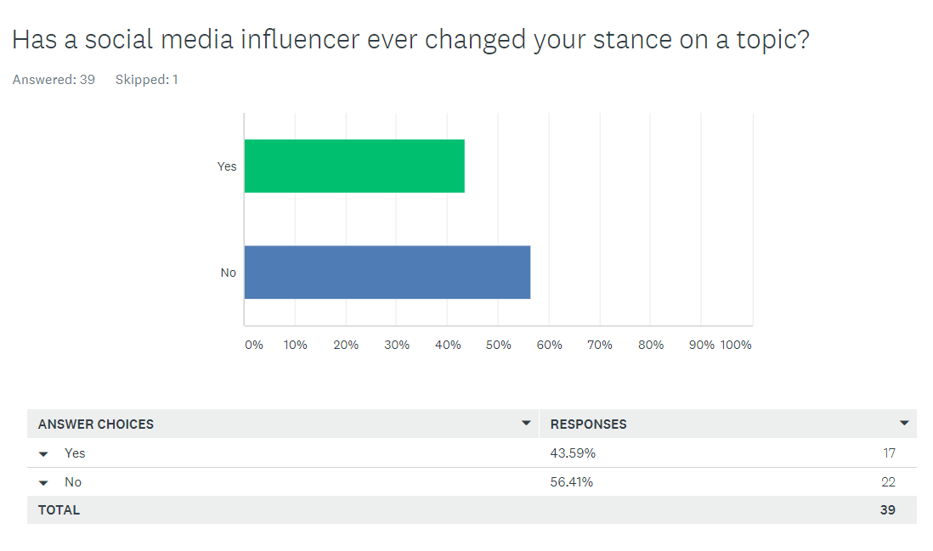

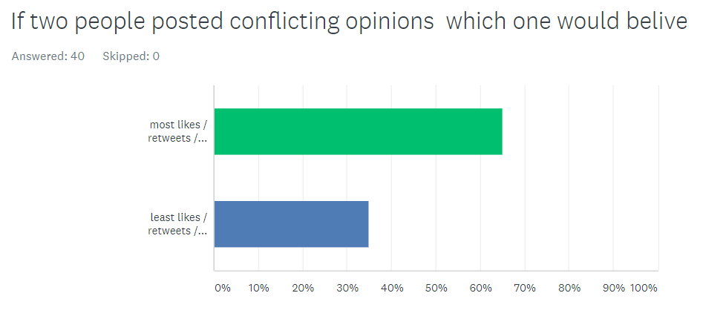Although 62% of individuals felt their opinion had been changed, only 43% stated that a social media influencer had changed their opinion on a topic (figure 4). Even though this is a less amount, it still provides critical information that people follow what an influencer has said. This could be related to the popularity or likeability of the influencer (figure 5). This is supported by (Tucker, 2011) “Popularity can be driven by both quality and match, and a narrow-appeal product can be popular if its quality is believed to be high.”

Figure Supporting evidence - popularity matters to an opinion

Figure Supporting evidence - social media influencer

## Has news appeared to you at a convenient time?

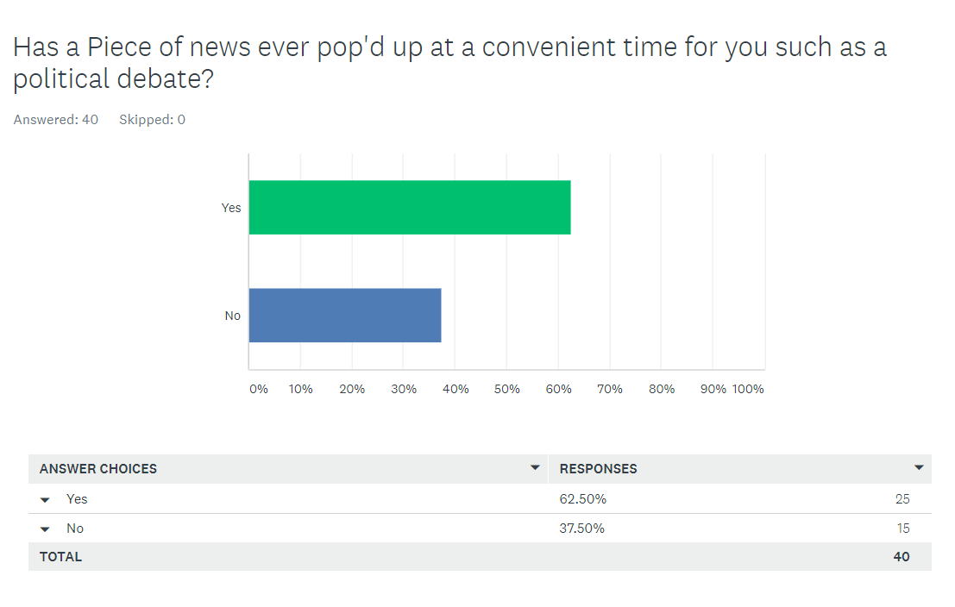63% of the individuals agree that subjects pop up at ideal times (figure 6). Like just before an election. For example, makes It easy for users / fake accounts to create a vast amount news articles, that could be easily discovered supported by (Gianluca Stringhini, 2012)“The number of followers can also be inflated by robot’ (or fake) followers purchased to inflate a brand’s follower count.” This states how easy it is for a user to seem popular on the platform causing more users to believe what they tweet without further evidence as well as it is possible the ‘fake’ accounts can share this information and support it making it extremely hard to distinguish what is true and not true.

Figure Supporting evidence - convenient news articles

## 

## Telling the difference between real and fake news?

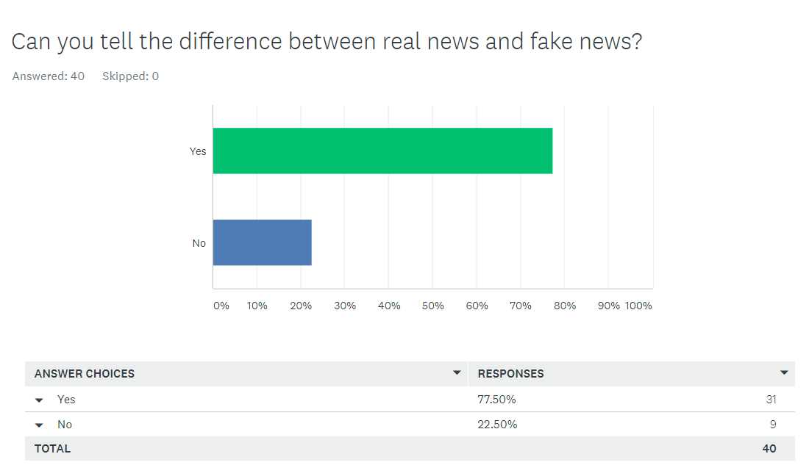

Although individuals are strongly adamant that they can spot the difference between fake news (figure 7), a whopping amount of 77% of users agreed.

Figure Supporting evidence – detecting fake news

### Detecting fake news continuation.

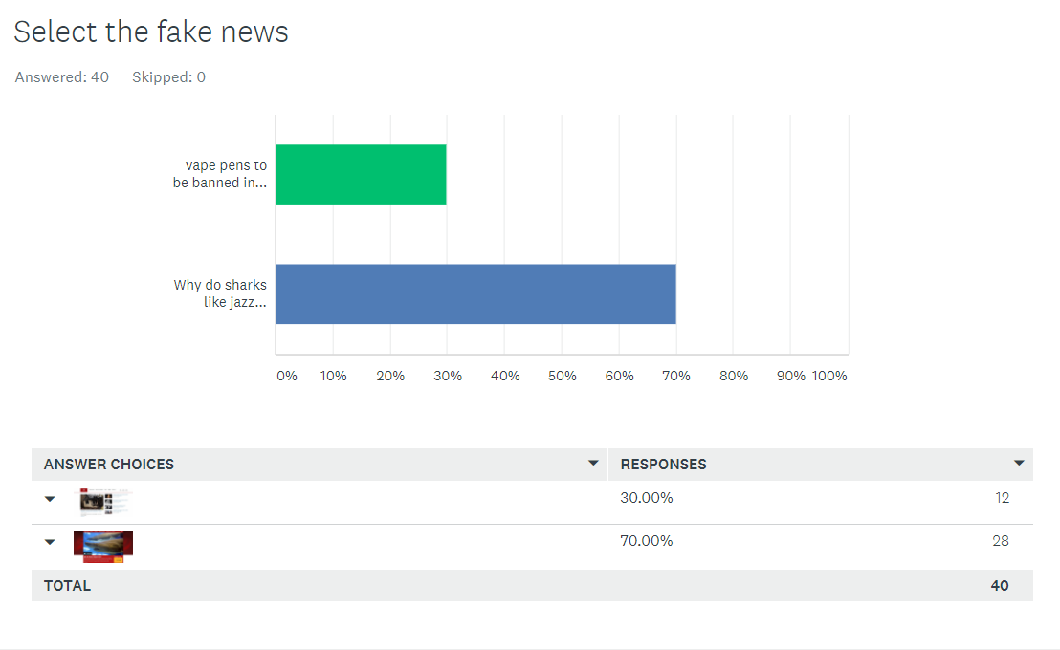Next, participants were asked to select a fake news article (figure 8). A large number of participants assumed that the article (figure 9) named “Why do sharks like jazz music?” was a fake news article but actually (figure 10)“Vape pens to be banned in the UK” was. This shows that most users do not research a news article and that they just believe the first piece of news provided.

Figure Supporting evidence - users cannot detect fake news

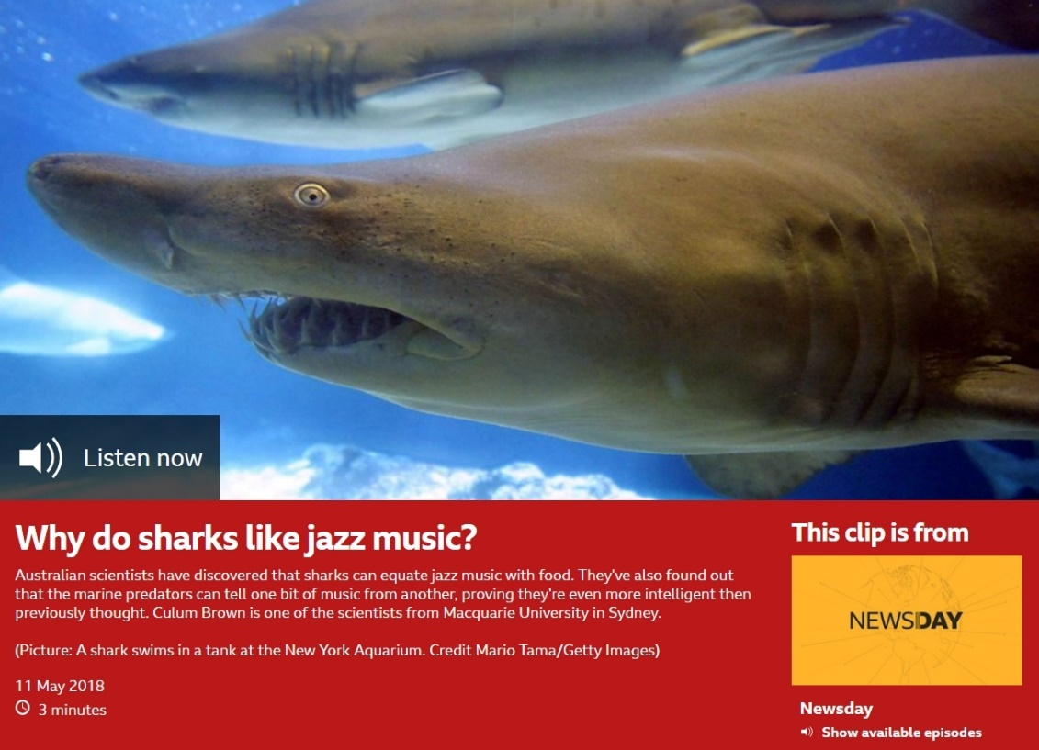

Figure Do sharks like jazz news article (Tama/Getty, 2018)

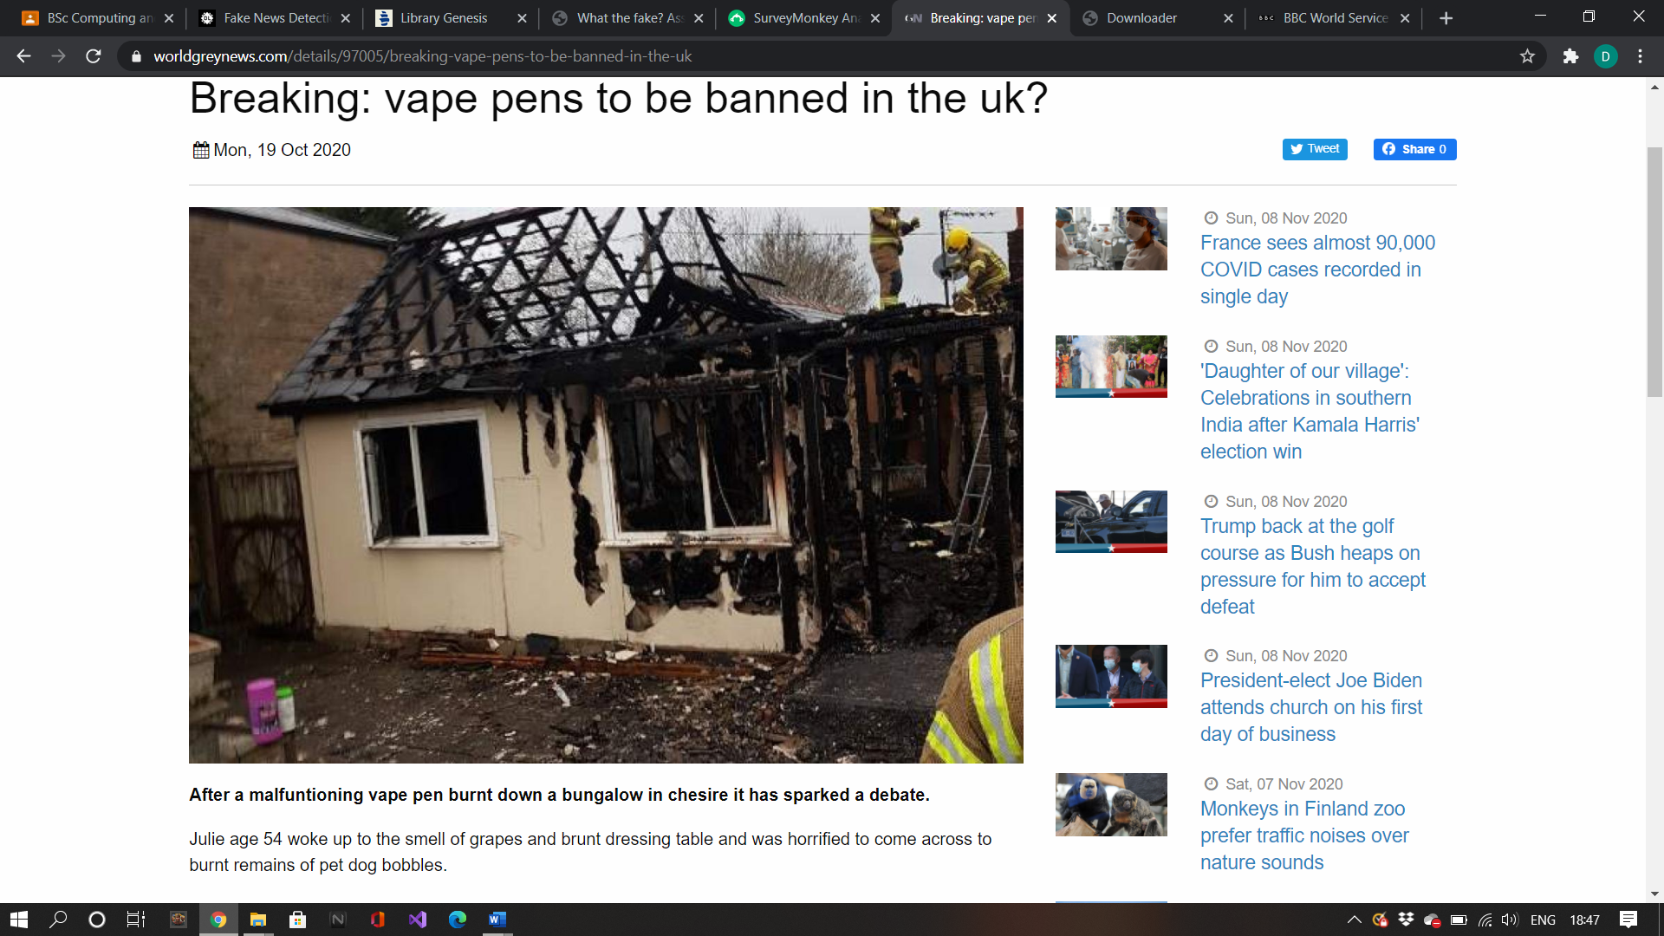

Figure Vape pens to be banned in the UK? news article (Smallwood 2020)

# The most frequent social media platform used to gather news

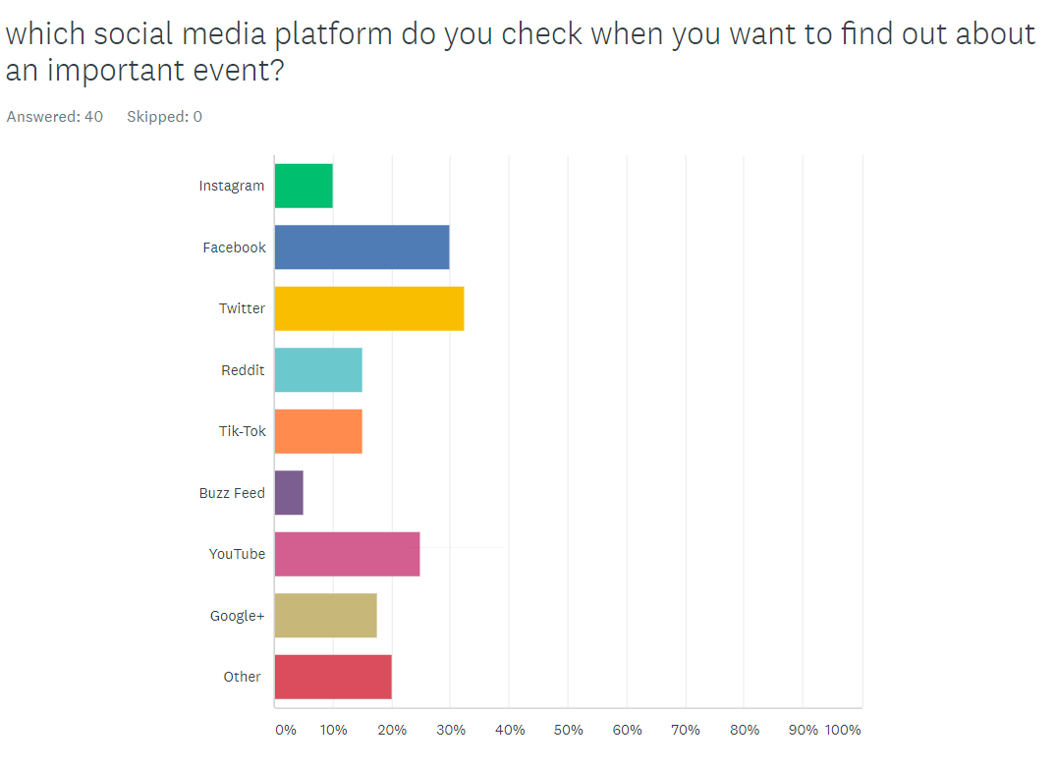As stated in this graph (figure 11), most participants from the survey use Twitter to check the news. Therefore, this document is focused largely on Twitter than no other social media app or website.

(Soboleva, 2018) “The popularity of Twitter has allowed organisations to promote products.”

Figure Supporting that twitter was the most frequent

# The frequency of viewing social media

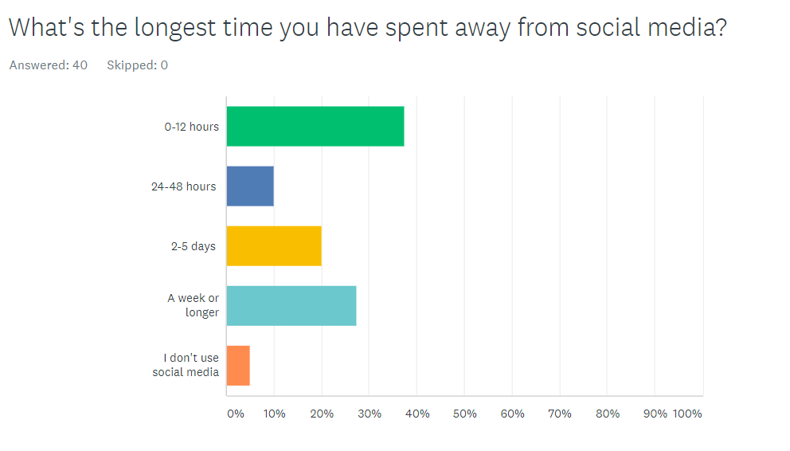This question (figure 12) shows that users are becoming obsessed with their social media accounts and checking their devices more frequently.

Figure supporting how frequent social media is checked

# Conclusion

In conclusion, the research gathered has shown that there is a lot of strong evidence that, it’s extremely easy to create trending news topics, false accounts and information. When hearing a lot of voices state the same opinion even though they may not be true it is more susceptible to being believed (figure 13), This is also supported by (Edgington, 2017)“Though spam is not always defined as a form of false information, it is somehow similar to the spread of misinformation which refers to the ‘inadvertent sharing’ of wrong information when users are not aware of the nature of messages they disseminate “

This could always be speculation as the personal survey conducted had 40 users answer it.

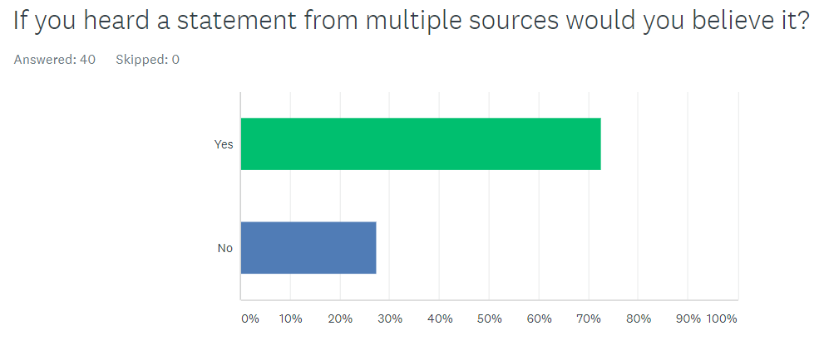

Figure Supporting Evidence repeated information

# Bibliography

Edgington, K. B. (2017). *Analysis of philanthropic opportunities to mitigate the disinformation/ propaganda problem.* Menlo Park, California, United States: William and Flora - Hewlett Foundation. Retrieved November 10th, 2020, from https://hewlett.org/wp-content/uploads/2017/11/Hewlett-Disinformation-Propaganda-Report.pdf

Gianluca Stringhini, M. E. (2012). *Poultry Markets: On the Underground Economy.* santa barbara: Computer Security Lab, University of California. Retrieved November 9th, 2020, from https://citeseerx.ist.psu.edu/viewdoc/download?doi=10.1.1.364.8560&rep=rep1&type=pdf

Smallwood, D. (2020, October 19th). Are *Vape Pens to be banned in the UK?* Retrieved from world renews: https://www.worldgreynews.com/97005/breaking-vape-pens-to-be-banned-in-the-uk

Soboleva, A. (2018). *Marketing with Twitter: investigating factors that impact the effectiveness of tweets.* Western Sydney: thesis. Retrieved November 8th, 2020, from http://hdl.handle.net/1959.7/uws:47360

Tama/Getty, M. (2018, May 11th). *Why do sharks like jazz music?* Retrieved from BBC Newsday: https://www.bbc.co.uk/programmes/p066vnpd

Tucker, C. A. (2011). *How Does Popularity Information Affect Choices? A Field Experiment.* Chicago: INFORMS. doi:https://doi.org/10.1287/mnsc.1110.1312

Zi Chu, S. G. (2010). *Who is Tweeting on Twitter: Human, Bot, or Cyborg?* Williamsburg, Fairfax: The College of William and Mary, George Mason University. Retrieved November 10th , 2020, from https://www.academia.edu/2704229/Who_is_tweeting_on_twitter_human_bot_or_cyborg